**SQL JOINS and Views**

**SQL JOIN**

JOIN, as the name implies, means to combine something. In SQL, JOIN means to join two or more tables. A JOIN clause joins rows from two or more tables based on a common column.

There are different types of joins in SQL.

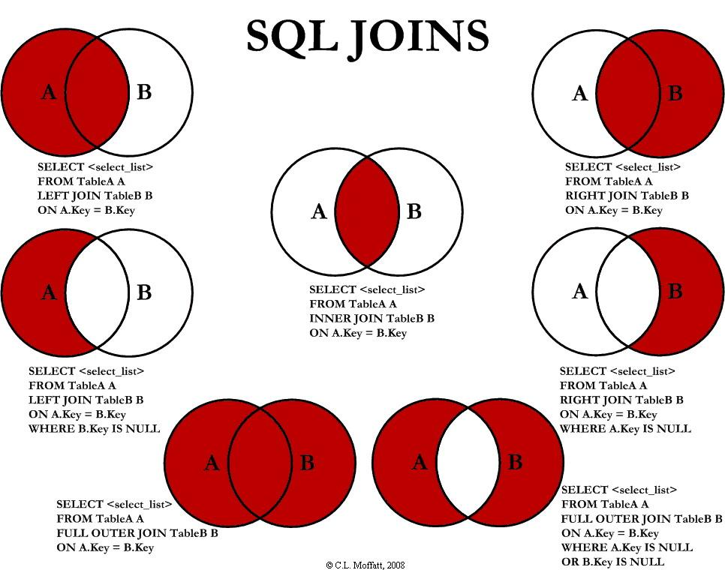

And the different joins are:

1. Inner Join

2. Left Join

3. Right Join

4. Outer Join

**INNER JOIN**

The INNER JOIN keyword selects records from both tables that have matching values.

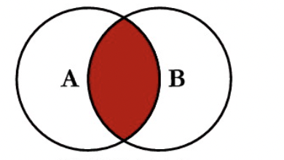

Syntax

SELECT *column(s)*

FROM *table_1*

INNER JOIN *table_2*

ON *table_1.column* = *table_2.column*;

Example

A selection from the "Employees" table is shown below.

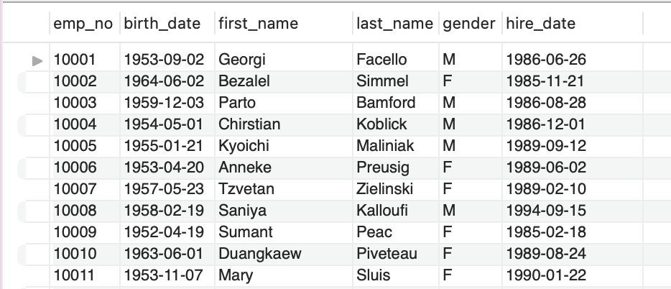

A selection from the "Salaries" table is shown below.

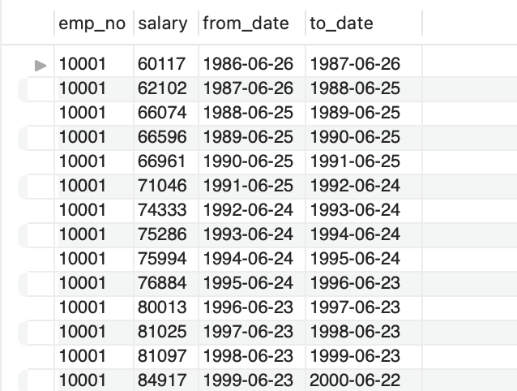

In the above two tables, the common column is emp_no. Therefore, we will use the inner join on this column to join both tables.

SELECT employees.first_name, salaries.salary

FROM employees

INNER JOIN salaries ON employees.emp_no = salaries.salary;

This returns the matching values of both tables.

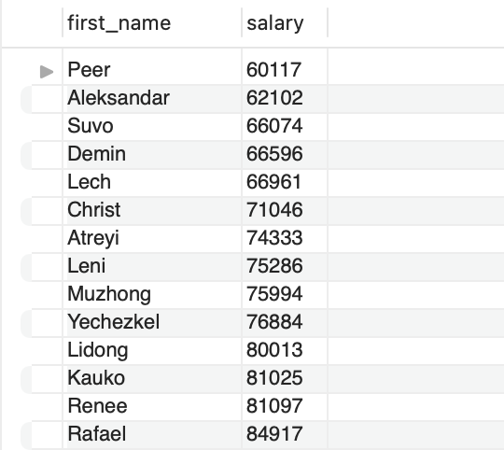

**LEFT JOIN**

Left join returns all of the values from the left table and any matching values from the right table; if no matching join values are found, it returns NULL.

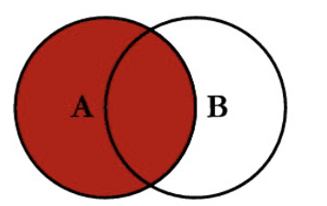

Syntax

SELECT table1.column1, table2.column2,....

FROM table1

LEFT JOIN table2

ON table1.column_field = table2.column_field;

Example

SELECT dept_emp.dept_no, salaries.salary

FROM dept_emp

LEFT JOIN salaries

ON dept_emp.emp_no = salaries.emp_no

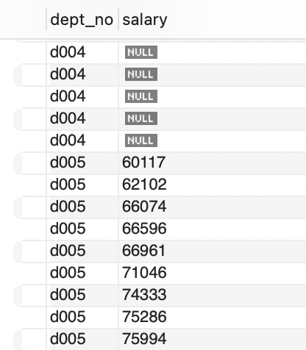

**RIGHT JOIN**

Right join returns all of the values from the right table and any matching values from the left table; if no matching join values are found, it returns NULL.

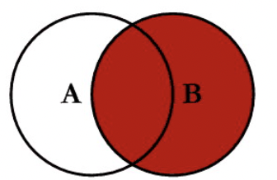

Syntax

SELECT table1.column1, table2.column2.....

FROM table1

RIGHT JOIN table2

ON table1.column_field = table2.column_field;

Example

SELECT first_name, title FROM titles

RIGHT JOIN employees

ON titles.emp_no = employees.emp_no

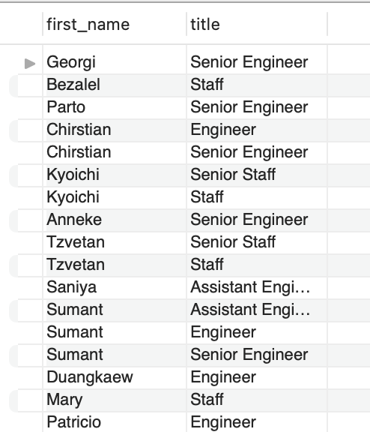

**OUTER JOIN**

The SQL FULL OUTER JOIN joins two tables based on a common column and selects records with matching values in these columns as well as any remaining rows from both tables.

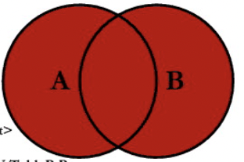

Syntax

SELECT table1.column1, table2.column2.....

FROM table1

FULL OUTER JOIN table2

ON table1.column_name = table2.column_name

WHERE condition;

Example

In MySQL, we use JOIN instead of OUTER JOIN.

SELECT first_name, last_name,salary

FROM employees

JOIN salaries

ON employees.emp_no = salaries.emp_no;

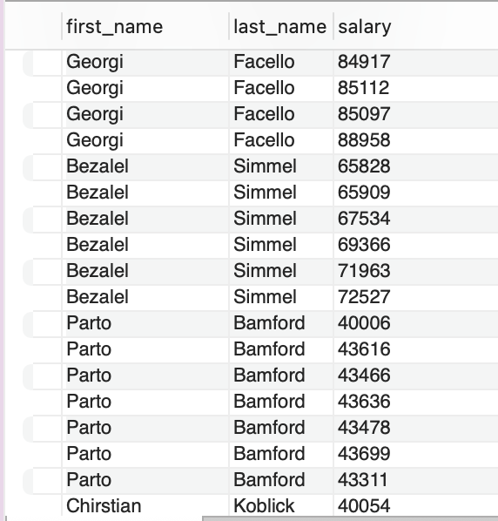

**UNION Operator**

The UNION operator joins the results of two or more SELECT statements. Within UNION, every SELECT statement must have the same number of columns. The columns must also be of the same data type. Every SELECT statement's columns must also be in the same order.

SELECT column(s) FROM table1

UNION

SELECT column(s) FROM table2;

Example

SELECT dept_no FROM dept_emp

UNION

SELECT dept_no FROM dept_manager;

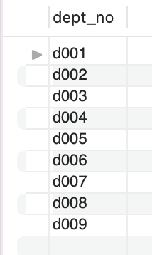

**UNION ALL OPERATOR**

UNION deals with distinct values, but UNION ALL returns duplicate values.

Syntax

SELECT *column_name(s)* FROM *table1*

UNION ALL

SELECT *column_name(s)* FROM *table2*;

Example

SELECT dept_no FROM dept_emp

UNION

SELECT dept_no FROM dept_manager;

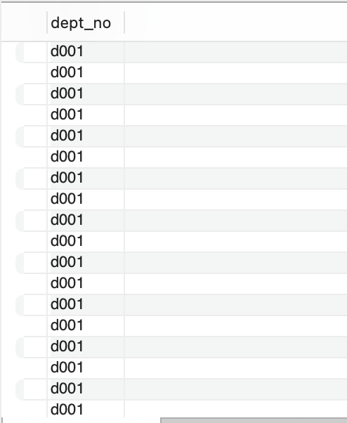

**INTERSECT OPERATOR**

The INTERSECT operator is used to find records that are shared by two SELECT statements or data sets. If a record exists in one query but not in the other, the INTERSECT results will exclude it.

Syntax

SELECT column1 , column2 ....

FROM table_names

WHERE condition

INTERSECT

SELECT column1 , column2 ....

FROM table_names

WHERE condition

**Example**

SELECT dept_no FROM dept_emp

INTERSECT

SELECT dept_no FROM dept_manager

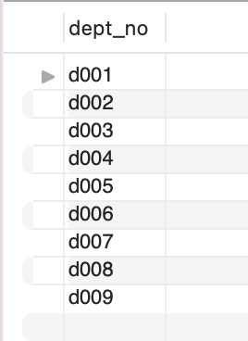

**SQL SUBQUERY**

A subquery is simply a query contained within another query. In other words, a Subquery is a query that is embedded within the WHERE clause of another SQL query.

Syntax

SELECT column_name

FROM table_name

WHERE column_name *expression operator*

( SELECT COLUMN_NAME FROM TABLE_NAME WHERE ... );

Example

Write an SQL query to find employees who earn more than the average salary of the employees.

SELECT emp_no

FROM salaries

WHERE salary >

( SELECT AVG(salary)

FROM salaries )

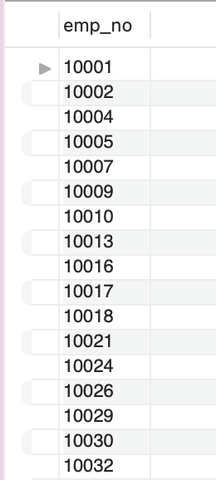

**SQL Views**

Views in SQL are essentially virtual tables. A view, like a real table in the database, has rows and columns. We can create a view by selecting fields from one or more database tables.

Syntax

CREATE VIEW view_name AS

SELECT column1, column2.....

FROM table_name

WHERE condition;

Example

Let us create a virtual table of emp_no, first_name and last_name using CREATE VIEW.

CREATE VIEW emp_names AS

SELECT emp_no, first_name, last_name

FROM employees;

Let us look at the emp_names table.

SELECT * FROM emp_names;

